**First Screen .**

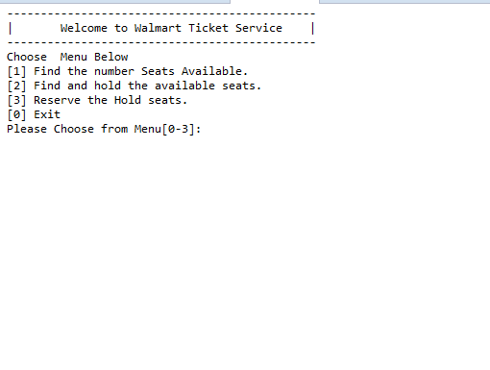

**Search the available seats**

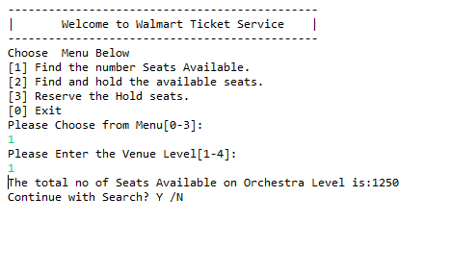

**Find and hold the seats Screen**

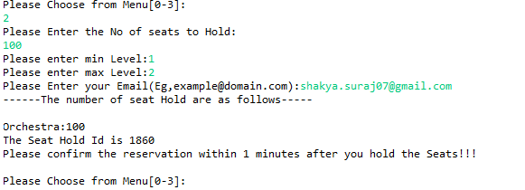

**Hold Expiration Screen**

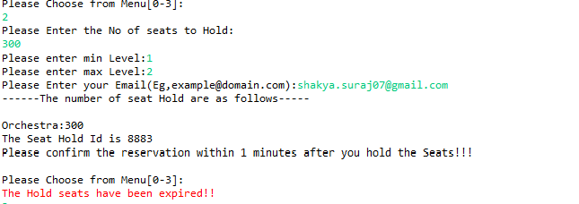

**Fail to Reserve Seat when Holds seats are Expired**

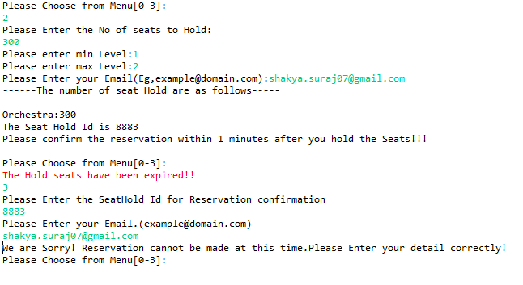

**Reservation Successful Screen**

